Check for duplicates
WITH CTE AS
(
select *, ROW_NUMBER() OVER(PARTITION BY transaction_id order by transaction_id) as row_num from dbo.sales
)
select *
FROM CTE
WHERE row_num > 1

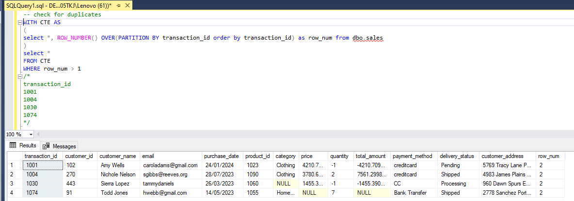

-- delete duplicates records
WITH CTE AS
(
select *, ROW_NUMBER() OVER(PARTITION BY transaction_id order by transaction_id) as row_num from dbo.sales
)
delete
FROM CTE
WHERE row_num > 1

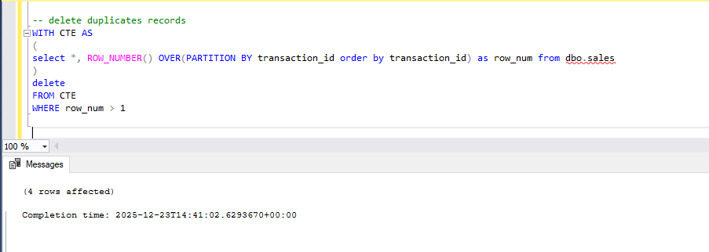

-- check for Null value
select * from dbo.sales
where transaction_id is null
or customer_id is null
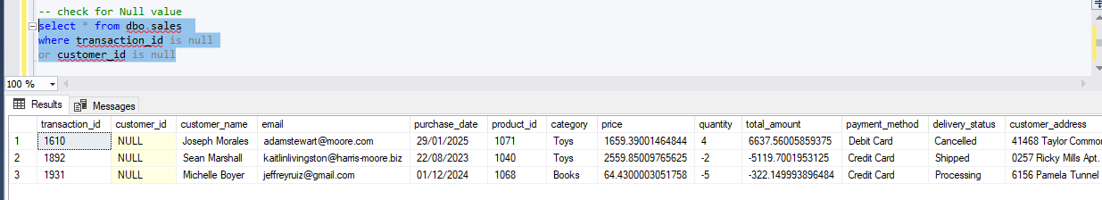
-------------------------------------------------------------------------------------

DECLARE @SQL NVARCHAR(MAX) = '';
SELECT @SQL = STRING_AGG(
'SELECT ''' + COLUMN_NAME + ''' AS ColumnName,
COUNT(*) AS NullCount
FROM ' + QUOTENAME(TABLE_SCHEMA) + '.sales
WHERE ' + QUOTENAME(COLUMN_NAME) + ' IS NULL',
' UNION ALL '
)
WITHIN GROUP (ORDER BY COLUMN_NAME)
FROM INFORMATION_SCHEMA.COLUMNS
WHERE TABLE_NAME = 'sales';

-- Execute the dynamic SQL
EXEC sp_executesql @SQL;
----------------------------------------------------------------------------------------------------------------------
-- treating Null values

select distinct category from dbo.sales

update dbo.sales
SET category ='Unknown'
where category is null

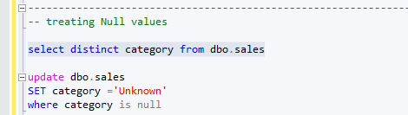

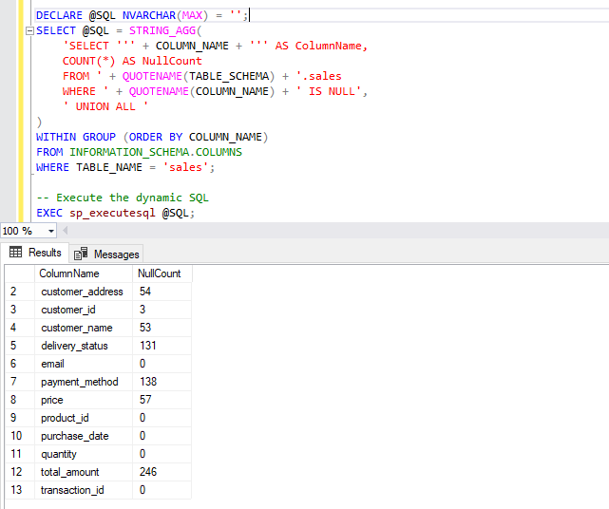
-- treating Null values

select distinct category from dbo.sales

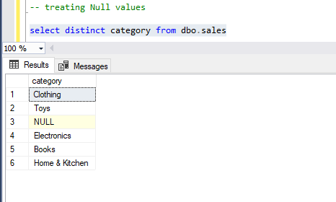
--- catagory Unknown

update dbo.sales
SET category ='Unknown'
where category is null
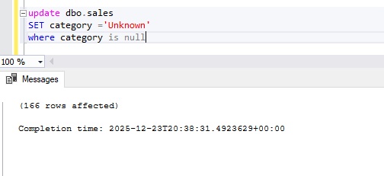
select distinct payment_method from dbo.sales

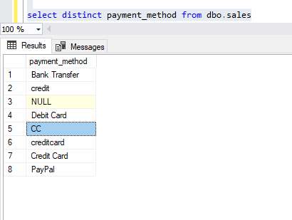

update dbo.sales
SET payment_method ='Credit Card'
where payment_method IN ('credit','CC','creditcard')

update dbo.sales
SET payment_method = 'Cash'
where payment_method IS NULL

select distinct payment_method from dbo.sales
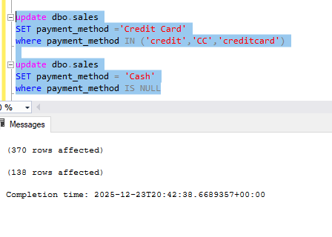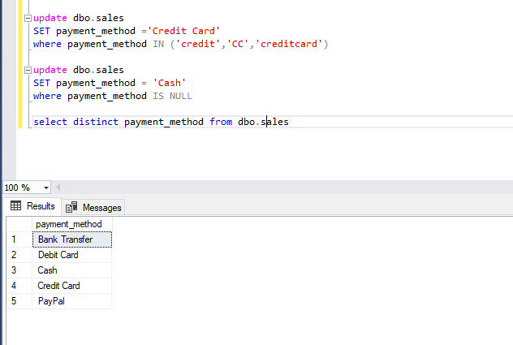

select distinct payment_method from dbo.sales

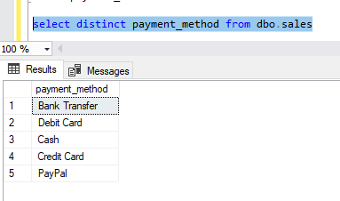
select distinct delivery_status from dbo.sales
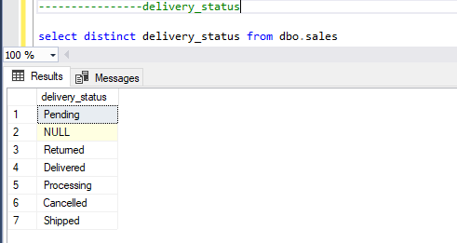

update dbo.sales
SET delivery_status = 'Not Delivered'
where delivery_status IS NULL

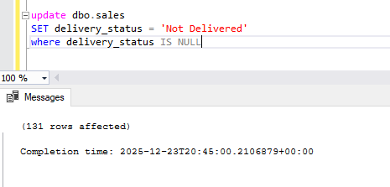
select distinct delivery_status from dbo.sales

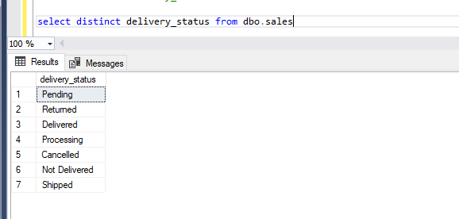

select email from dbo.sales where email not like '%@%'

update sales
set email= null
where email not like '%@%'
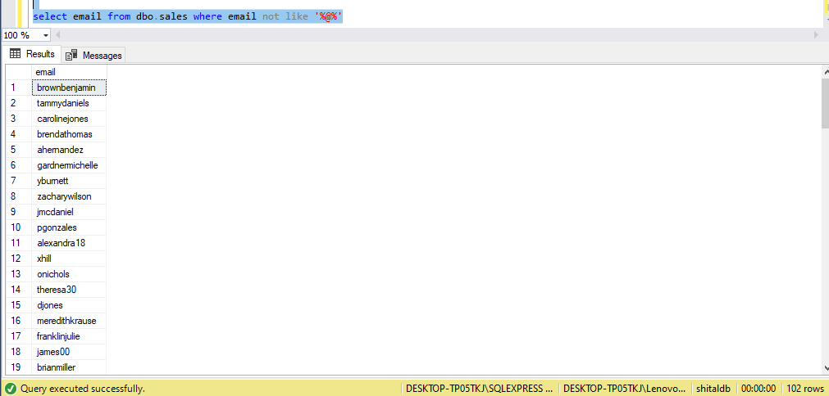

--- check data type of column

SELECT COLUMN_NAME, DATA_TYPE
FROM INFORMATION_SCHEMA.COLUMNS
WHERE TABLE_NAME='sales'
